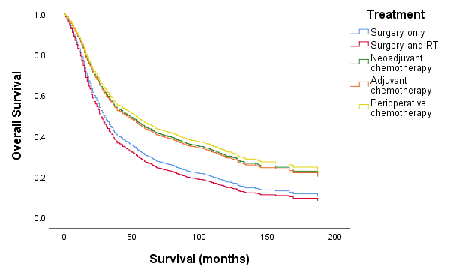

|  |  |  |  |  |  |
| --- | --- | --- | --- | --- | --- |
| **No. at risk** | **0** | **50** | **100** | **150** | **200** |
| **Surgery only** | 678.5 | 166.0 | 69.5 | 15.5 | 0.5 |
| **Surgery and RT** | 23.0 | 5.5 | 2.5 | 0.5 | - |
| **Neoadjuvant chemotherapy** | 273.5 | 25.5 | 8.5 | - | - |
| **Adjuvant chemotherapy** | 802.0 | 216.0 | 66.5 | 6.5 | - |
| **Perioperative chemotherapy** | 150.5 | 10.5 | 2.0 | - | - |

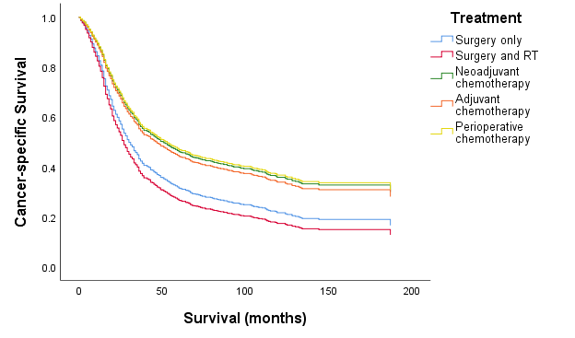

|  |  |  |  |  |  |
| --- | --- | --- | --- | --- | --- |
| **No. at risk** | **0** | **50** | **100** | **150** | **200** |
| **Surgery only** | 556.0 | 124.0 | 50.5 | 12.5 | 0.5 |
| **Surgery and RT** | 20.0 | 5.5 | 2.5 | 0.5 | - |
| **Neoadjuvant chemotherapy** | 257.5 | 20.5 | 7.5 | - | - |
| **Adjuvant chemotherapy** | 728.0 | 182.0 | 59.5 | 6.5 | - |
| **Perioperative chemotherapy** | 146.5 | 10.5 | 2.0 | - | - |

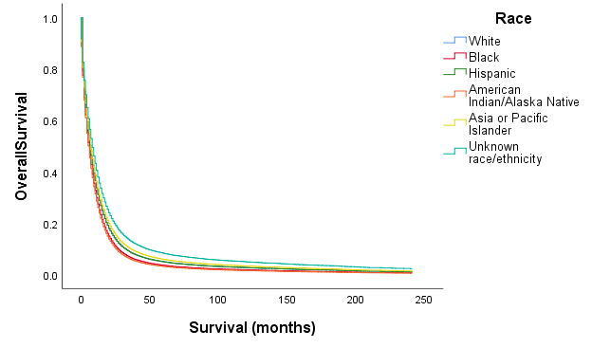

|  |  |  |  |  |  |
| --- | --- | --- | --- | --- | --- |
| **No. at risk** | **0** | **50** | **100** | **150** | **200** |
| **Non-Hispanic White** | 1439.5 | 335.0 | 124.0 | 25.0 | 0.5 |
| **Black** | 205.0 | 51.0 | 22.0 | 4.5 | - |
| **Hispanic** | 211.0 | 39.0 | 15.0 | 5.0 | - |
| **American Indian** | 13.5 | - | - | - | - |
| **Asian or Pacific Islander** | 188.5 | 46.5 | 20.5 | 5.0 | - |
| **Unknown race** | 4.0 | 1.5 | 0.5 | - | - |

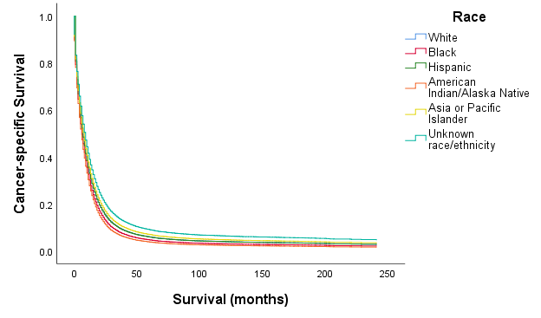

|  |  |  |  |  |  |
| --- | --- | --- | --- | --- | --- |
| **No. at risk** | **0** | **50** | **100** | **150** | **200** |
| **Non-Hispanic White** | 1276.0 | 262.0 | 96.0 | 20.0 | 0.5 |
| **Black** | 176.0 | 43.0 | 17.0 | 2.5 | 0.0 |
| **Hispanic** | 191.0 | 32.0 | 12.0 | 3.0 | - |
| **American Indian** | 12.0 | - | - | - | - |
| **Asian or Pacific Islander** | 158.5 | 38.5 | 16.5 | 3.0 | - |
| **Unknown race** | 4.0 | 1.5 | 0.5 | - | - |